***JAIVIK CHAUHAN***

***19BIT0039***

***VIT-VELLORE***

***DATA ANALYTICS***

***SMARTBRIDGE***

1. COGNOS

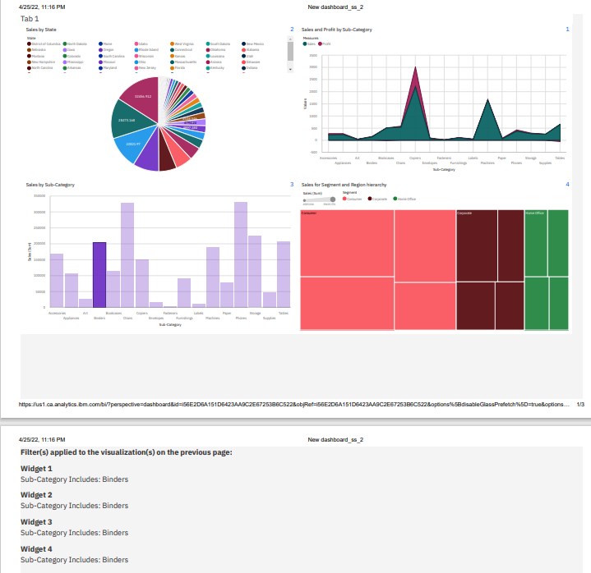

**WATSON STUDIO:**

1. **SPACE SHUTTLE**

DATA REFINERY:

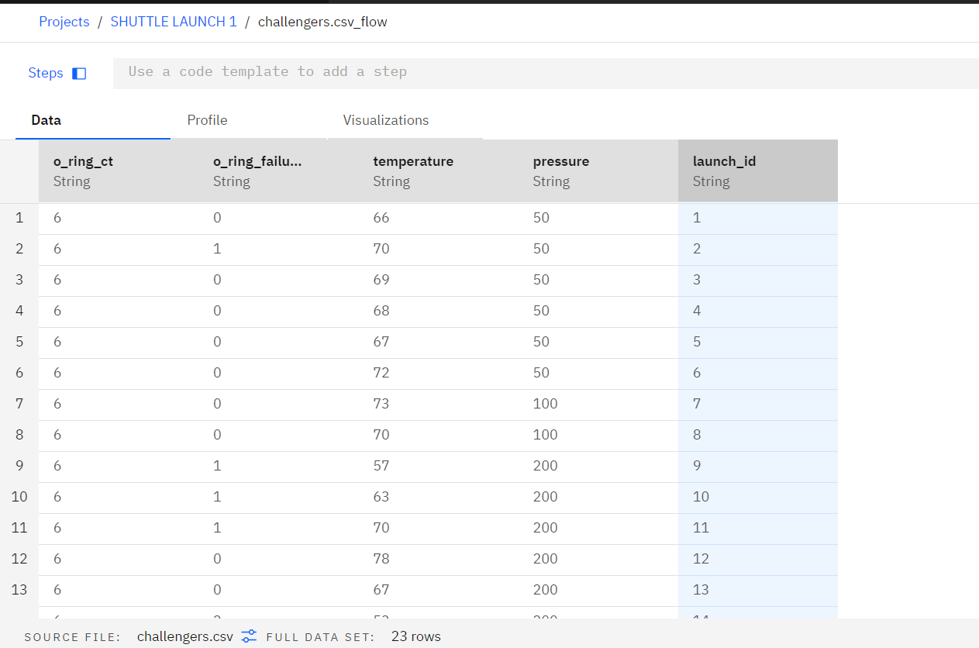

SPSS:

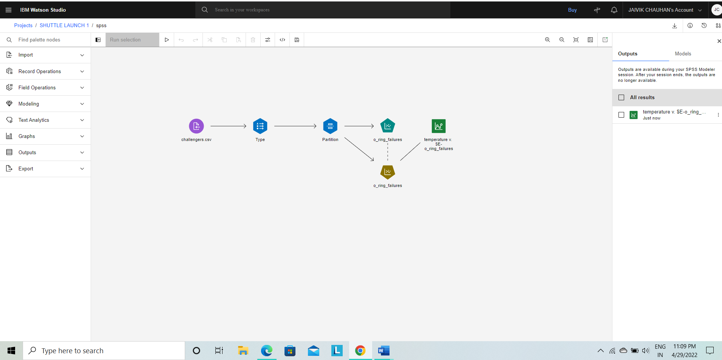

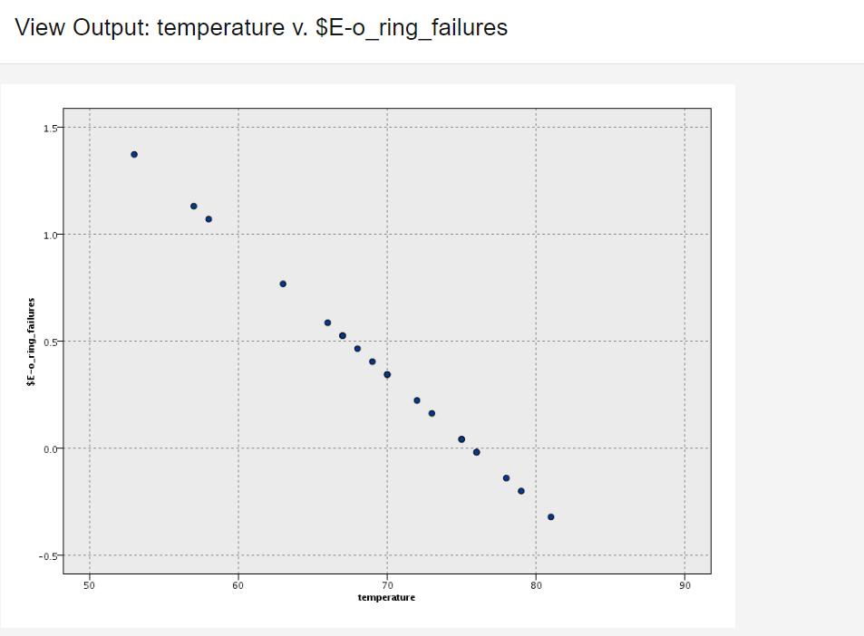

1. **MALL CUSTOMER**

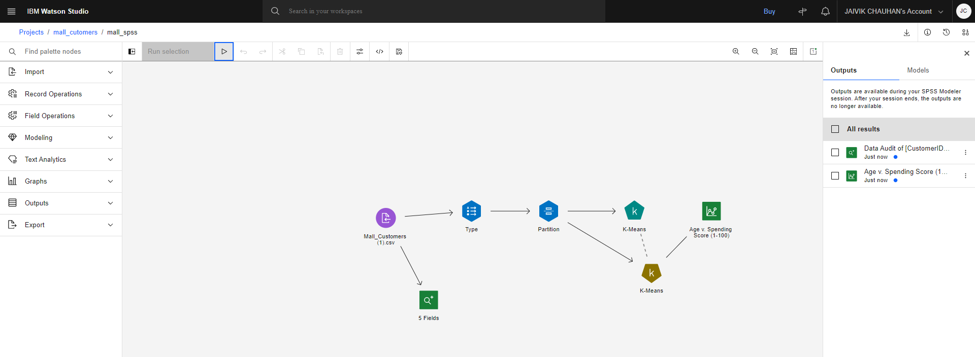

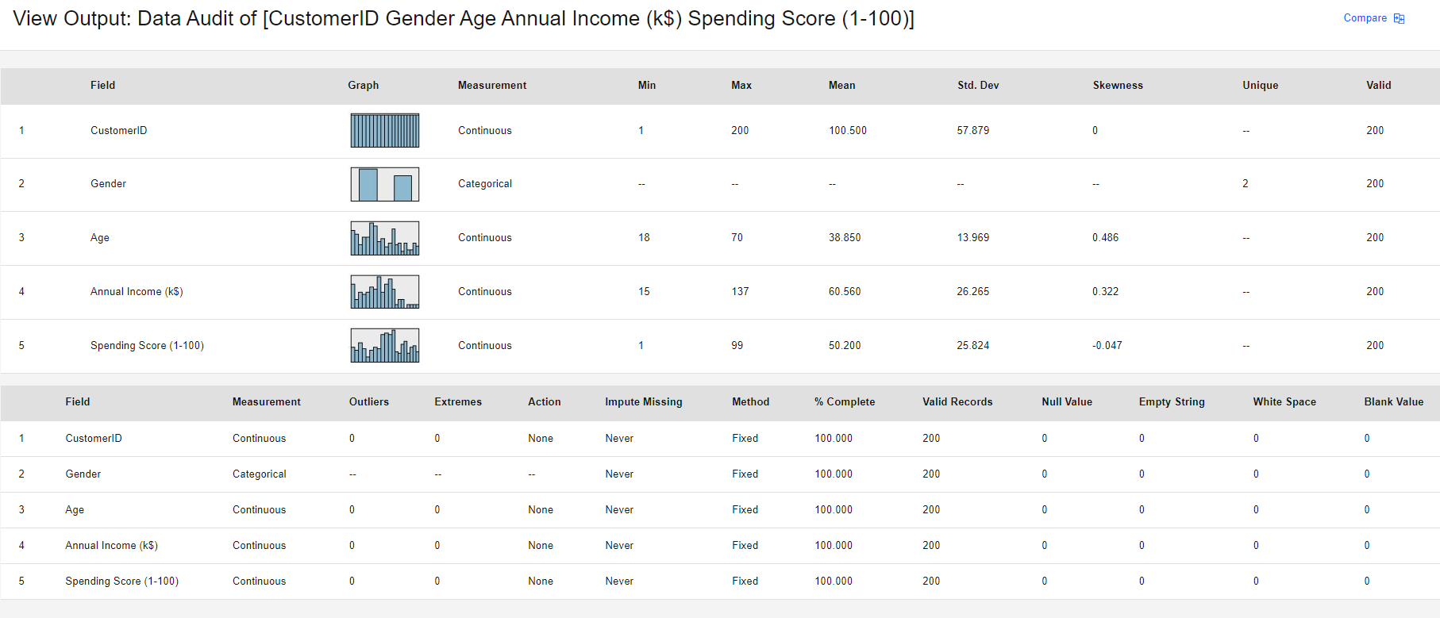

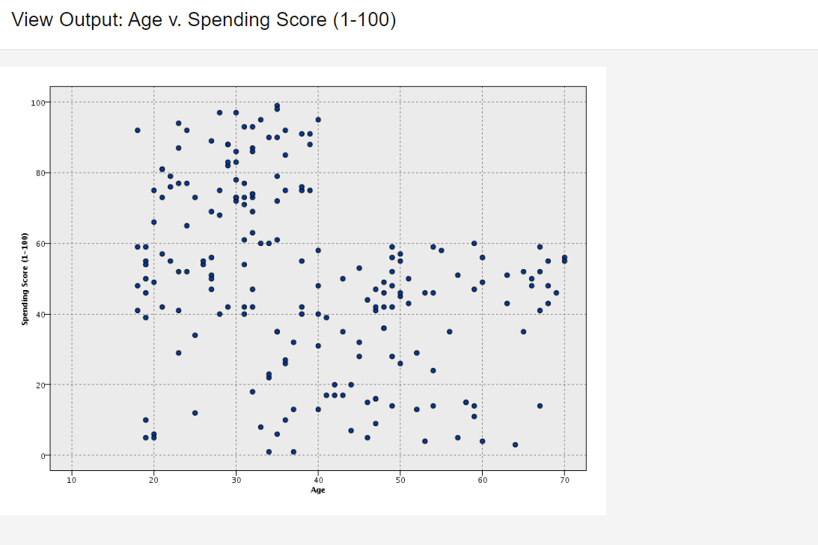

1. **DIABETES:**

**DATA REFINERY:**

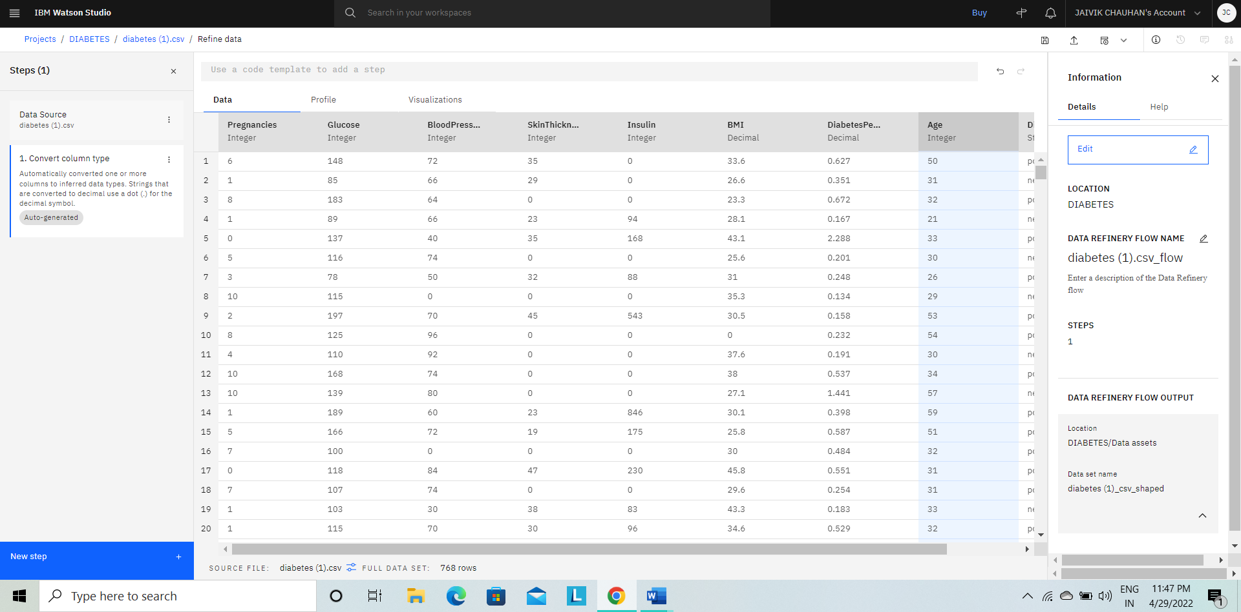

**SPSS:**

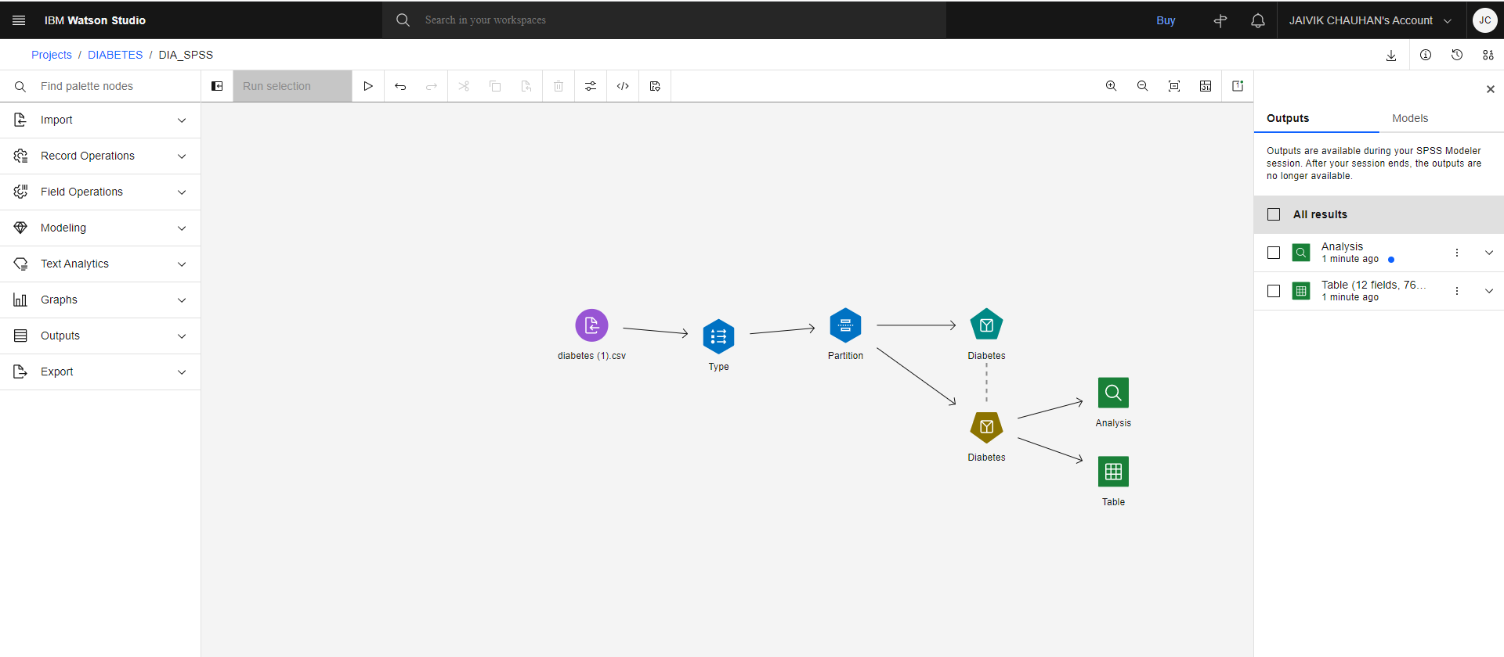

**ANALYSIS:**

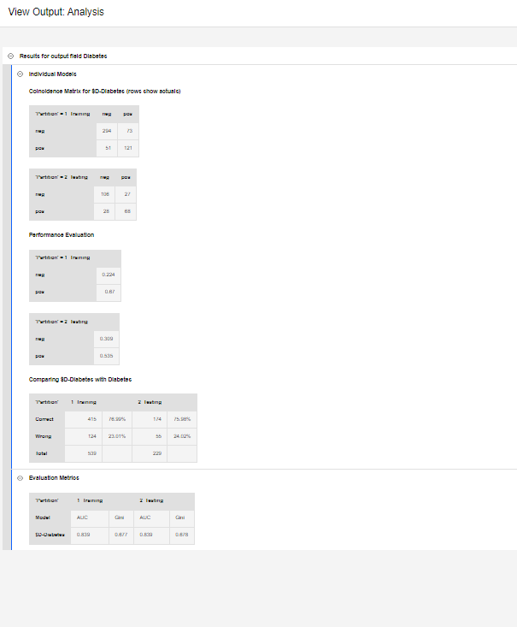

**TABLE:**

